International Conference of Police Chaplains Region 2

Regional Training Seminar - February 10th – 13th, 2020

Cannon Beach Christian Conference Center, Cannon Beach, Oregon

Chaplaincy 2020: “Resiliency
…in it for the Long Run”

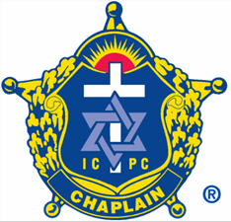

International Conference of Police Chaplains - Region 2

Chaplain Mike Ryan, Regional Director
209 246th Way SE, Sammamish, WA 98074
MRyan@bellevuewa.gov
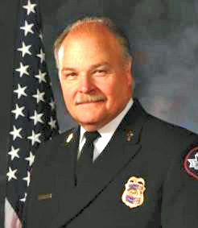
“Committed to Excellence in Training and Support”

A Note from Chaplain Mike Ryan, Region 2 Director

On behalf of our ICPC leadership, I want to welcome your participation in our annual ICPC Region 2 Regional Training Seminar. This year’s conference offers a balance of ICPC Basic Training along with advance courses designed to address challenges we all face.

We are honored to have Dr. Randy Rowland and Cindi Sinnema as our speakers this year. These two professionals bring with them a wealth of experience and perspectives for our encouragement and consideration.

For years on Sunday you'd find Pastor Randy Rowland addressing a congregation in Seattle's Greenwood neighborhood. But, during the fall he also spends many of his Sundays speaking to a much larger group of followers. That’s because on those days Randy can be found high above Century Link Field as the official public address announcer for the Seattle Seahawks. Randy says, “My job is to help 68 thousand people be frothing Seahawk fans and make this the loudest most impossible place for another team to play." So, while Sunday's may be a pastor's busiest day each week, Randy has no plans to stop “speaking” to the devoted Hawk 12’s congregating at The Clink.

Randy is also a professor at Fuller Seminary in Seattle where he taught a course on chaplaincy to several dozen military chaplains, many of whom were corresponding with Randy after class from the fields of battle in Iraq and Afghanistan. From this perspective and decades of pastoral experience with high-performance personalities in high-stress settings, Randy brings a fresh perspective to the history and challenges of current-day chaplaincy.

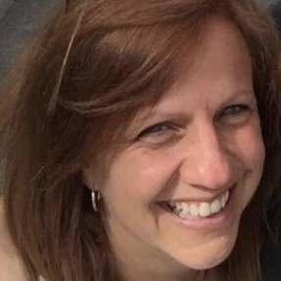
Cindi Sinnema is known as the “Disaster Pastor;” principally because she has responded to over 100 natural disasters!
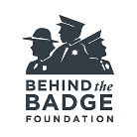
Currently serving as a Program Specialist on the staff at Behind the Badge Foundation, she has provided support to Washington State’s law enforcement agencies, families and communities after an officer has died or suffered serious injury in the line of duty - including providing ongoing assistance to those who continue to serve and protect our communities, and their families.

Cindi has worked in the field of traumatic response and community support for over 30 years. She attended the University of Washington and worked with Separation and Loss Services at Virginia Mason and then as a chaplain. She has assisted individuals, families and communities who have been impacted by disasters, both natural and man-made. She has worked with first responders all over the country to provide support and follow up services to those impacted by the unexpected; and trained community volunteers to provide assistance in the aftermath of trauma and loss. When addressing the topic of resiliency, Cindi brings a wealth of both knowledge and personal first-hand experience to the conversation.

Our experience together at Canon Beach Conference Center affords many opportunities to strengthen and make new friendships, deepen our resilience, and raise the bar as proactive chaplains to our charges in law enforcement.

As ever, if I or our Area Representatives can serve you in any way, please let us know. Thanks in advance for being with us.

Stay safe and God bless, Mike

TOPICS COVERED AT THE 2020 RTS

The agencies we serve expect us to be trained and equipped to serve them with expertise and excellence. The 2020 RTS provides a unique opportunity to make the progress needed toward ICPC’s highly recognized credentialing.

BASIC CLASSES

Each year the RTS offers 6 of the 12 ICPC Basic Courses. This allows new Chaplains to complete all the Basic Courses in two years, if the RTS is the only training they can attend.

The 2020 RTS includes the following ICPC Basic Courses:

B04 - Ceremonies and Events – Diane Peterson
B05 - Confidentiality and Legal Liability – Tom Jonez
B08 - Law Enforcement Family – Mike Neil
B09 - Substance Abuse – Mike Ryan
B10 – Suicide – Tito Rivera
B12 - Sensitivity and Diversity – Diane Peterson

ADVANCED CLASSES

Advanced classes are designed to cover topics of interest for Chaplains desiring to refresh and renew the latest understanding on critical areas of interest.

This year includes the following ICPC Advanced courses:

Advanced Class #1 – Stress Management for Trauma Service Responders - Mike Dismore

Advanced Class #2 – Soul Care for the Chaplain - Gordon Harper

Advanced Class #3 – Disaster Response: Knowing Your Roles and Responsibilities - Mike Ryan

2020 RTS ICPC CERTIFIED INSTRUCTORS
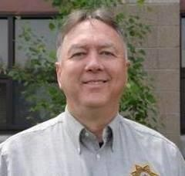
Chaplain Mike Dismore – Mike has been a pastor since 1978. He was a pastor with The Salvation Army in Colorado, Oregon, Idaho, and California and later with Family Bible Church in San Jose, California. He served as a volunteer for Region 2 by updating and maintaining the Regional website as needed. In May, 2004 he and his family moved to Redmond, Oregon where he serves as a chaplain with Central Oregon Police Chaplaincy. Mike is married and has two children.

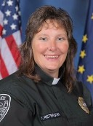
Chaplain Diane Peterson – Dianne is Executive Director of Alaska Police & Fire Chaplains Ministry and the Commander for Alaska with Chaplain Fellowship Ministries. Diane is board certified in Clinical Chaplaincy and Pastoral Counseling through the College of Pastoral Supervision and Psychotherapy(CPSP). Licensed and ordained thru Trinity Full Gospel in 2009. Diane has extensive training in CISM, Crisis Negotiation and suicide prevention and post-vention. Additionally, she co–facilitates Survivor of Suicide meetings for those who loved ones have completed suicide. In 2016 Chaplain Peterson received the Presidential Call to Service Lifetime Achievement Award.

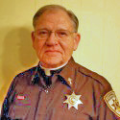
Chaplain Gordon Harper – Gordon has been a hospital chaplain for over 30 years, a Fire Chaplain since 2002, and a Law Enforcement Chaplain since 2009 with both the Campbell County Sheriff and the Wyoming Highway Patrol. Prior to this he served as a pastor for over 45 years with a variety of churches in Nebraska and Wyoming. He is also currently the President of the Wyoming Law Enforcement Chaplain’s Association. Gordon has been married to his wife Cathy for 55 years; they have three children and 5 grandchildren.

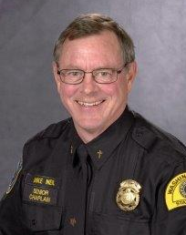
Chaplain Mike Neil – Mike is the Assistant Regional Director to Mike Ryan, and is the President and Founder of the Washington State Chaplain Foundation, and Senior Chaplain for the Washington State Patrol and the Department of Fish and Wildlife. Prior to his selection by the State Agencies as the Senior Chaplain, Mike’s background includes service for 30 years as a Fish and Wildlife Police Officer, including 15 years as a Police Firearms Instructor, and 16 years as a Police Dog Handler. He is the author and illustrator of an African adventure novel, The Miracle of Africa, and a recognized professional artist. Mike has been married to his wife, Susan, since 1973 and resides in Gig Harbor, Washington.

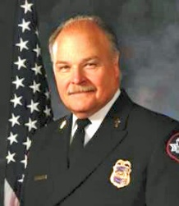
Chaplain Mike Ryan – Mike Ryan has served as a police / fire chaplain since 1985; his first 18 years as a chaplain for the San Francisco Police Department. He moved to Washington in 2002 and has served with the Bellevue Police and Fire Departments, Medina PD and Eastside Fire and Rescue. Chaplain Ryan's has skills and expertise in Disaster Mental Health, including work with survivors from the Oklahoma City Bombing, the Loma Prieto earthquake and the 9/11 WTC response. He is a certified expert in Traumatic Stress Management and a trainer in disaster mental health for Public Health Seattle King County's Disaster Mental Health Reserve Corp. Mike is the ICPC Region 2 Regional Director.
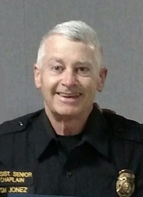
Dr. Tom Jonez - serves as the Assistant Senior Chaplain for the Washington State Patrol and Fish and Wildlife Chaplaincy. He has over thirty years’ experience in business leadership. Currently, as President/CEO of Plumbline Management & Plumbline Media Group, Tom is a strategic management and market expansion consultant, an award-winning video producer, and oversees a growing media services team. In 1992 Tom was CEO of a company that, under his leadership, was listed by INC Magazine on their “INC 500” compilation as the 101st fastest growing company in America. Tom’s background includes extensive experience in developing and overseeing non-profit organizations. Dr. Jonez has a graduate degree in Strategic Leadership. Tom and his wife Faye currently reside in Gig Harbor, Washington.
Chaplain Calik ‘Tito’ Rivera – Tito serves the Blaine County Sheriff Department in Idaho. He joined ICPC in 2010, holds a Master Credential, is a certified instructor, and has served on the ICPC International Committee. He is also a member of the National Critical Incident Stress Management Team. Tito is the ICPC Region 2 Area Representative in Idaho Tito opened three churches for Spanish & Portuguese communities in Wood River Valley and transferred them to other leaders. Tito and his wife Dartha love family and friends, and enjoy traveling whenever they can.

2020 REGION 2 - RTS SCHEDULE

Monday, February 10, 2020

8:30-11:30 AM Area Representatives Breakfast and Meeting

1:30-3:00 PM Set up and Preparation for RTS – Regional Team

3:00-5:00 PM Registration and Check-In

4:00 - 5:30 PM Session 1 Basic Class B08 – Law Enforcement Family
(Pacific Room 2nd Floor)

5:30 PM Dinner in Pacific View Lodge Dining Room (1st Floor)

7:30 PM Session 2 – Welcome and Opening Session – Mike Ryan
(Everyone, Fireside Room in the Pacific View Room, 2nd Floor)

Tuesday, February 11, 2020

7:30 AM Registration

8:00 - 9:00 AM Breakfast in Pacific View Lodge Dining Room (1st Floor)

9:30 AM - 11:00 AM Session 3 – Cindi Sinnema – Session #1 – The Nature of Resilience
(Everyone, Fireside Room in the Pacific View Room, 2nd Floor)

12:00 -12:45 PM Lunch in Pacific View Lodge Dining Room (1st Floor)

1:00 - 2:30 PM Session 4 – Cindi Sinnema – Resilience for those We Serve
(Everyone, Fireside Room in the Pacific View Room, 2nd Floor)

3:00 - 4:30 - Session 5 - Session 5 Basic Class B05 – Confidentiality and Liability
(Pacific Room 2nd Floor)

Advanced Class #1 – Stress Management for Trauma Service Responders - Mike Dismore
(Fireside Room in the Beach Front Lounge, 2nd Floor)

5:30 PM Dinner in Pacific View Lodge Dining Room (1st Floor)

7:00 - 8:30 PM - Session 6 - Dr. Randy Rowland, Professor to Military Chaplains – Resilience on the Field of Battle
(Fireside Room in the Pacific View Room, 2nd Floor)

Wednesday, February 12, 2020

8:00-8:45 AM Breakfast in Pacific View Lodge Dining Room (1st Floor)

9:00 - 10:30 AM Session 7 - Cindi Sinnema – Session #3 – In it for Long Run
(Everyone, Fireside Room in the Pacific View Room, 2nd Floor)

10:45 AM - 12:15 PM

Session 6 Basic Class B04 – Ceremonies and Events
(Beach Front Lounge 2nd Floor)

Advanced Class #2 - Soul Care for the Chaplain - Gordon Harper
(Fireside Room in the Pacific Room 2nd Floor)

12:00 Lunch on Your Own

1:15 - 3:45 PM Session 8: Basic Class B10 – Suicide
(Pacific Room 2nd Floor)

4:00 - 5:30 PM Session 9 Basic Class B09 – Substance Abuse
(Pacific Room 2nd Floor)

6:00 - 7:30 PM Awards Banquet – Wear your uniform tonight!
(Pacific View Dining Room & Pacific View Room, 2nd Floor)

8:00 PM Fellowship/Snacks (Pacific Room)

Thursday, February 13, 2020

8:00-8:45 AM Breakfast in Pacific View Lodge Dining Room (1st Floor)

9:00 - 10:30 AM - Session 10 Basic Class B12 – Sensitivity and Diversity
(Pacific Room 2nd Floor)

Advanced Class #3 – Disaster Response: Knowing Your Roles and Responsibilities - Mike Ryan

10:45 - 11:30 AM Session 11 - Special Attention and Region 2 Business Meeting: Mike Ryan
(Everyone, Beach Front 2nd Floor)

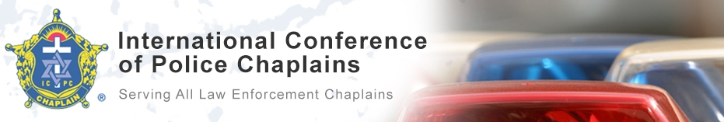

Established in 1973, the International Conference of Police Chaplains (ICPC) is a 501 (C) 3 organization providing global training to law enforcement chaplains, liaison officers, and agency administrators.

Training provides continuing education units (CEUs), as well as equipping attendees to better serve their communities.

Available to all, our quarterly publication The Journal provides current articles and other information pertinent to law enforcement chaplaincy.

Membership benefits include access to educational material and a network of mutual support, as well as:

Lending Library—available through the Member’s Only Section.

Credentialing—Substantiate ongoing education by pursuing the following levels: Basic, Liaison, Senior, Master, Diplomate, and Fellow (see our Credentialing pamphlet for compliance requirements).

ICPC provides support and assistance to law enforcement agencies in establishing or improving chaplaincy programs.

For more information about ICPC or Starting a Law Enforcement Chaplaincy booklet contact:

ICPC
PO Box 5590
Destin, FL 32540
(850) 654-9736
icpc@icpc.gccoxmail.com
www.icpc4cops.org
ICPC
PO Box 5590, Destin
FL 32540
(850) 654-9736
icpc@icpc.gccoxmail.com
www.icpc4cops.org
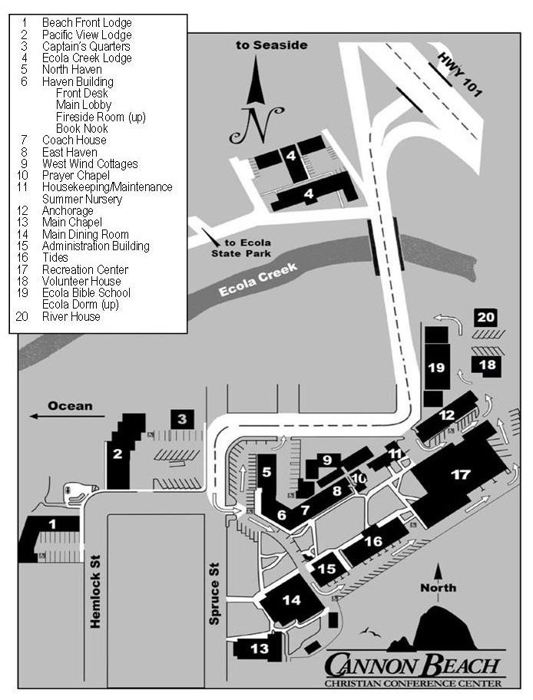
Street Address: 289 N. Spruce, Cannon Beach, OR 97110
Phone: 503.436.1501 - Fax: 503.436.1047 - Toll Free: 800.745.1546

